**Create a freestyle job and create a choice paramter for each task.**

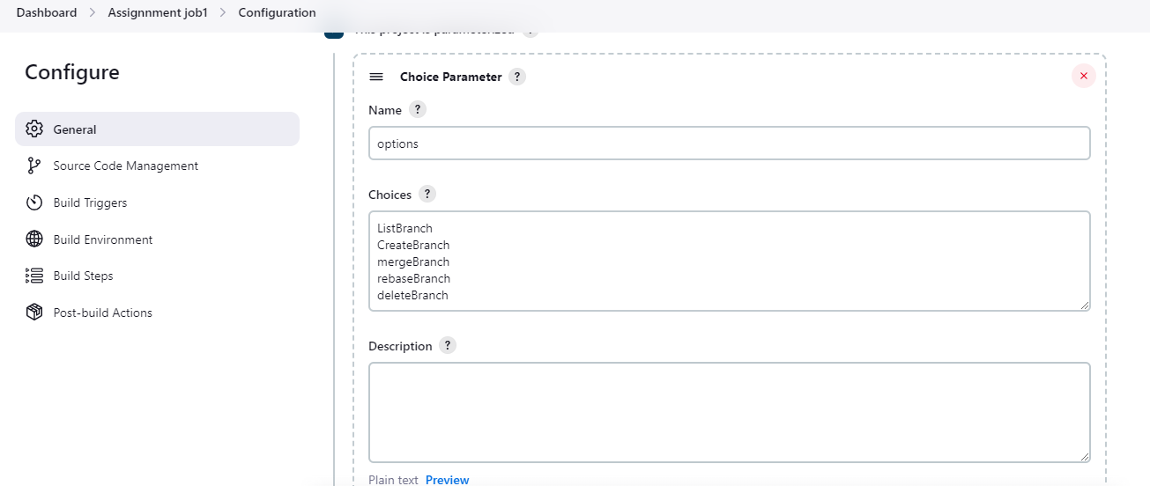

# Create a freestyle job and create a string paramter.

# 

# Do this for branchname2 & file name

# Put git repo url in SCM section

# 

# Write the sheel command

# 

# Configure email notifications

# 

# >Notification received for failed & success received on mail

# 

# For slack

# 

# Notification Received:

# 

# JENKINS ASSIGNMENT01 Part 2

# Create a freestyle job and create a choice paramter for each task.

# 

# 

# write shell command in build step section.

# 

# 

# Console output

# 

# Server host details output

# 